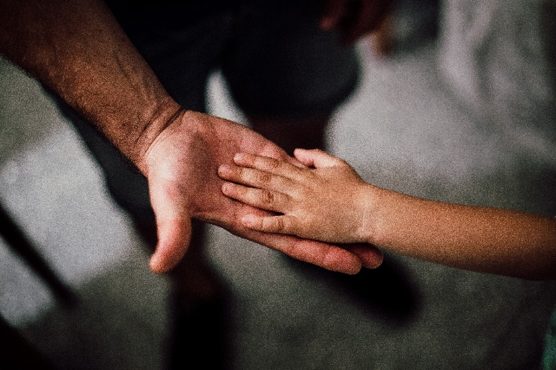

**Nuzhat Tabassum Progga**

**ID: 18101005**

**Sk. Yeasin Kabir Joy**

**ID: 18101020**

**Orphanage management system**

[Document subtitle]

**INDEX**

Content Page Number

1. Project Name and Description 2
2. ER Diagram 3
3. Schema Diagram 4
4. Query 5-20
5. Picture of Table Data 21-30
6. Appendix 31-73

**Orphanage management system**

An orphanage is a place where remain orphans. There works some employee. Every employee work in individual department. Every child of the orphanage is taken care by some of employee who work in the guide post, they are called the advisor of the child. There are some Building for their resident and class, stuff office. Each room contains five child. Every child goes to school of the orphanage. Teachers of their own school tech them. There is donation system also. Every year some donor donates some amount for the orphan child. They donate money only to those employees who work in account department. People can adopt child from here, in these case address, phone number and some of their information is record by the management system.

**Entities**

* **Child-** Hold information of children.
* **Employee-** Hold record of the people who works in the orphanage.
* **Department-** Hold record of which employee work in which department.
* **Advisor-** Hold record of which guide take care of which child.
* **School-**Hold record of child present class and their present class teacher.
* **Teacher-** Hold record of the teachers.
* **Building-** Keep the information of buildings.
* **Resident-** Hold record of which child exist from which building, which floor and which room.
* **Donor -**keep record of people who donate for children.
* **Donation -**This entity holds records of donation.
* **Adopt-** hold record of adopted child and the people who adopt the child.

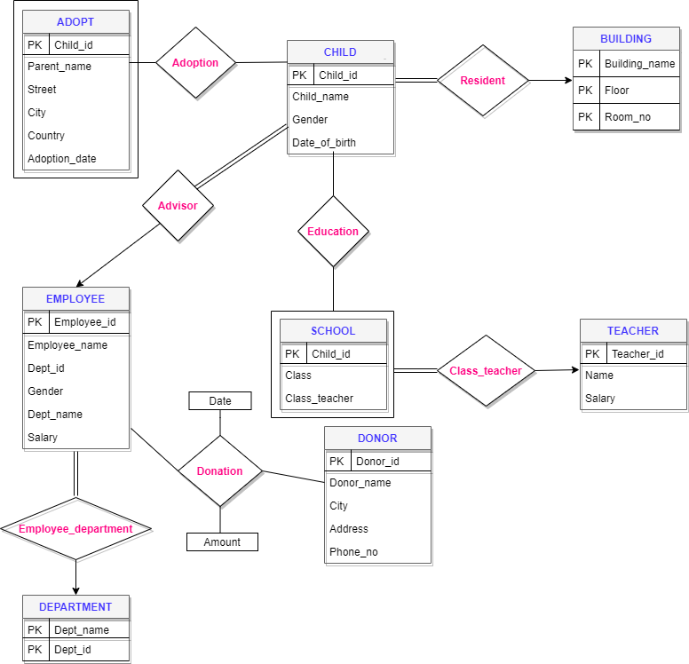**ER Diagram**

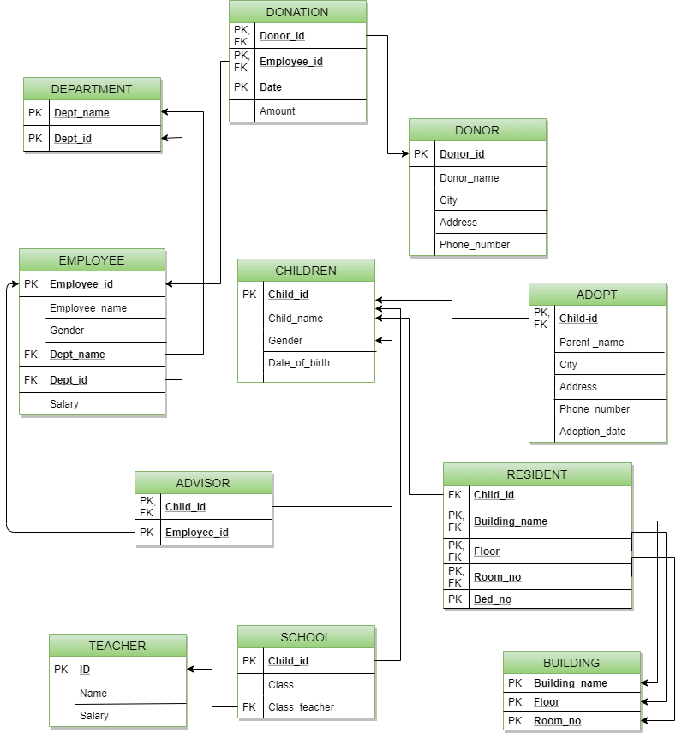 **Schema Diagram**

**Query**

1. Find all male children.

select * from CHILD

where Gender='Male'

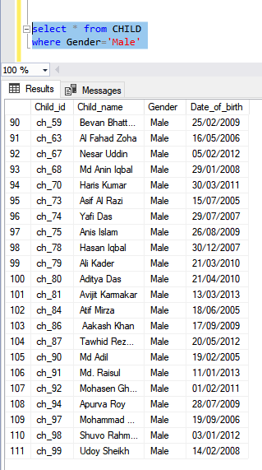

2. Find all female children.

select * from CHILD

where Gender='Female'

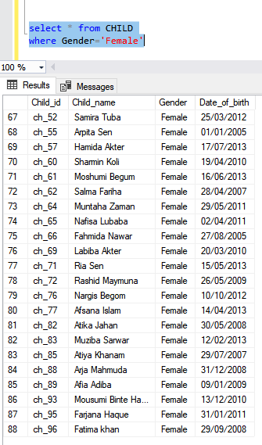

3. Find all children whose name ends with ‘al’

select * from CHILD

where Child_name like '%al'

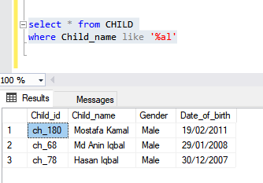

4. Find all the female children of age seven.

select count(Child_id) as number_of_children from

(select * from CHILD

where

Date_of_birth like '%2013' and Gender = 'Female') A

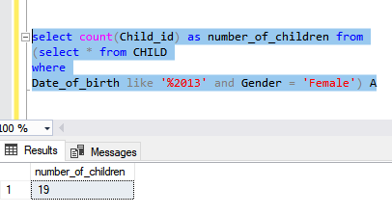

5. Find all donor of 2018.

select Donor_id,Amount from DONATION

where Date like '%2020'

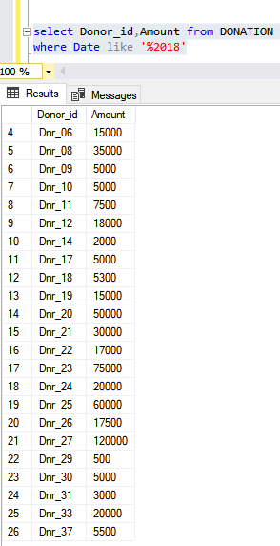

6. Find total donation of year 2019.

select sum(Amount)

from DONATION

where Date like '%2019'

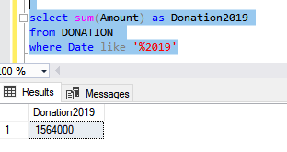

7. Find the donor id and amount who donate highest amount of money at a time.

select top 1 * from(

select Donor_id, Amount from DONATION

)

A

order by Amount desc

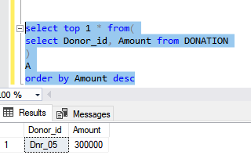

8. Find all donor who lives in Dhaka.

select * from DONOR

where city='Dhaka'

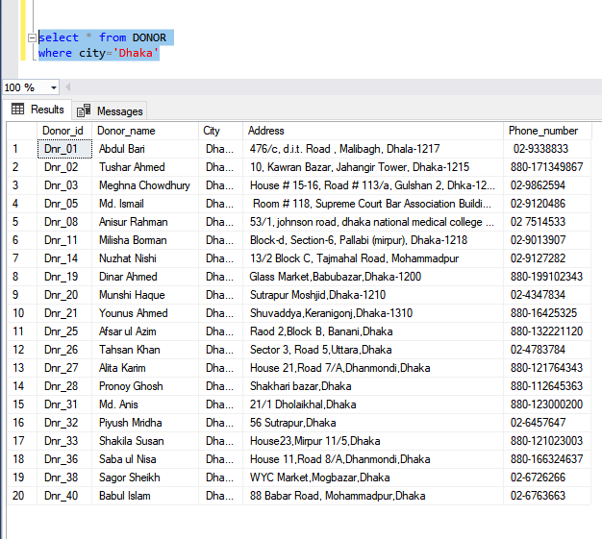

9. Find donors who lives in Chittagong and donates more than 40000.

select distinct DONATION.Donor_id, Donor_name from DONOR,DONATION

where

DONOR.Donor_id=DONATION.Donor_id and city like 'Chi%' and Amount>40000

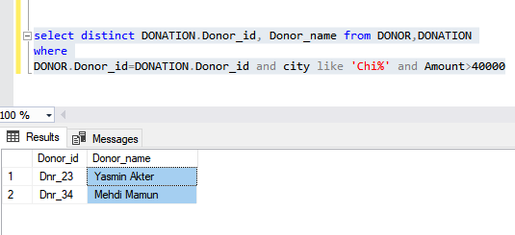

10. Find all employee who works at Administration.

select * from EMPLOYEE

where Dept_name='Administration'

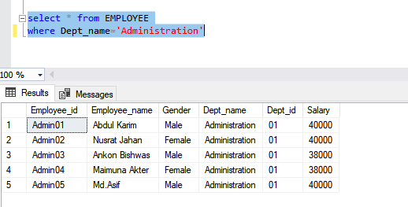

11. Find average salary and name of those departments where average salary is greater than 30000

select Dept_name,avg(salary)

from EMPLOYEE

group by Dept_name

having avg(salary)>30000

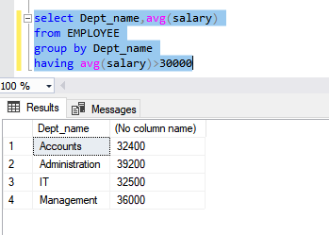

12. Find the largest salary of all Employees.

(select distinct Salary_

from EMPLOYEE)

except

(select distinct s.Salary

from EMPLOYEE as S, EMPLOYEE as R_where S.Salary< R.Salary )

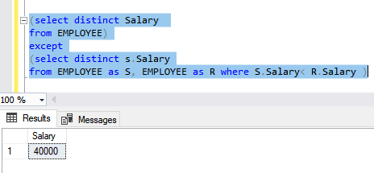

13. Find all parents name and address of adopted child who lives in Khulna.

select parent_name , Address from ADOPT

where City='Khulna'

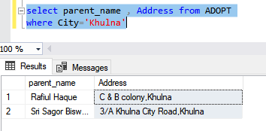

14. Find parents name who lives in Dhaka and adopted children in 2018.

select parent_name from ADOPT

where City='Dhaka' and Adoption_date like '%2018'

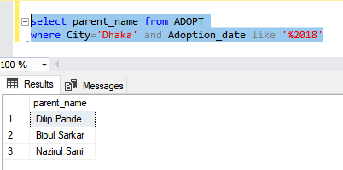

15. Find all the advisors.

select * from EMPLOYEE

where Employee_id like 'gd%'

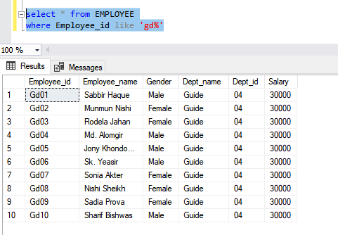

16. Find the total salary of food department Employee.

select sum(Salary) FoodSalary

from EMPLOYEE

where Employee_id like 'fd%'

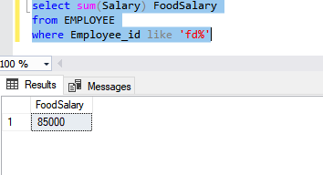

17. Find the teachers who are not class teacher.

(select Teacher_id from TEACHER)

except

(select Class_teacher_id from SCHOOL)

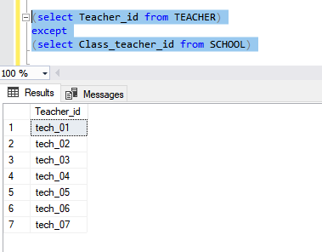

18. Find the teachers whose salary is in the range of 26000 and 30000.

select * from TEACHER

where Salary between 26000 and 30000

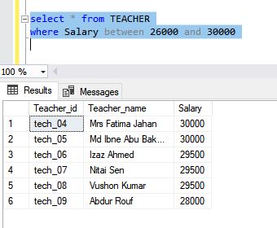

19. Find the children name who lives in East Building 2nd floor.

select Child_name

from CHILD as S,RESIDENT as T

where S.Child_id=T.Child_id and Building_name='East Building' and FLOOR='2'

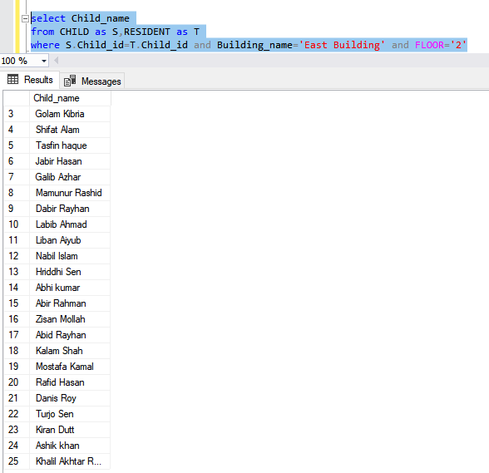

21. Find the date of birth of the students who are in class 7.

select Date_of_birth

from SCHOOL as X ,CHILD as Y

where X.Child_id=Y.Child_id and class ='7'

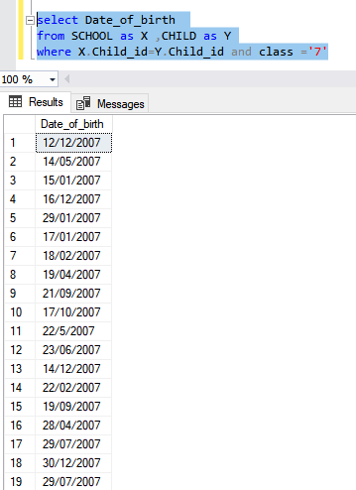

21. Find top three classes that has most student.

select top 3 class

from (

select count ([child_id]) as num_of_stu, [class]

from SCHOOL

group by [Class] )

A

order by num_of_stu desc

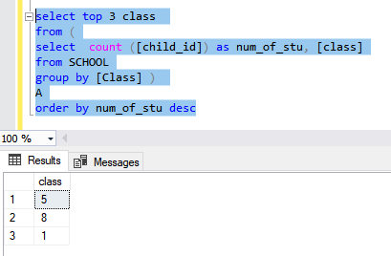

22. Find the children’s name who lives in north building 1st floor and age is 7.

select Child_name

from CHILD as S,RESIDENT as T

where S.Child_id=T.Child_id and Building_name='North Building' and Date_of_birth like '%2013'

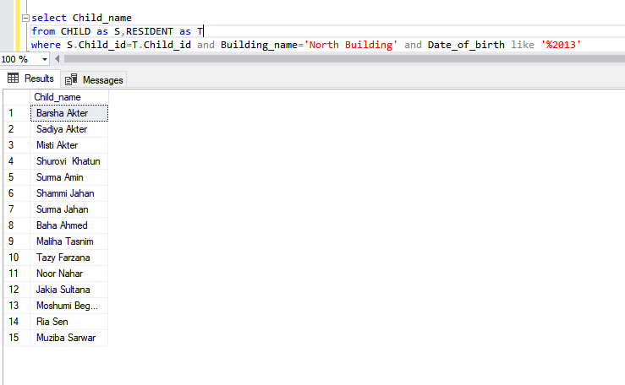

23. Find out all empty rooms.

(select Building_name,Floor,Room_no from BUILDING)

except

(select Building_name,Floor,Room_no from RESIDENT)

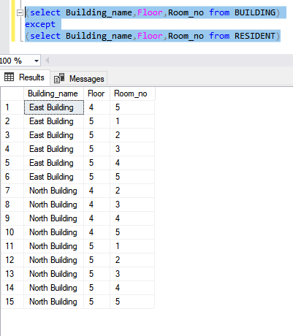

24. Find top 2 city with less donor.

select top 2 city

from (

select count ([Donor_id]) as num_of_donor, [City]

from DONOR

group by [City] )

A

order by num_of_donor

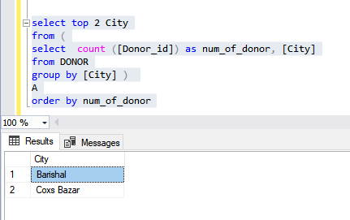

**Table Data**

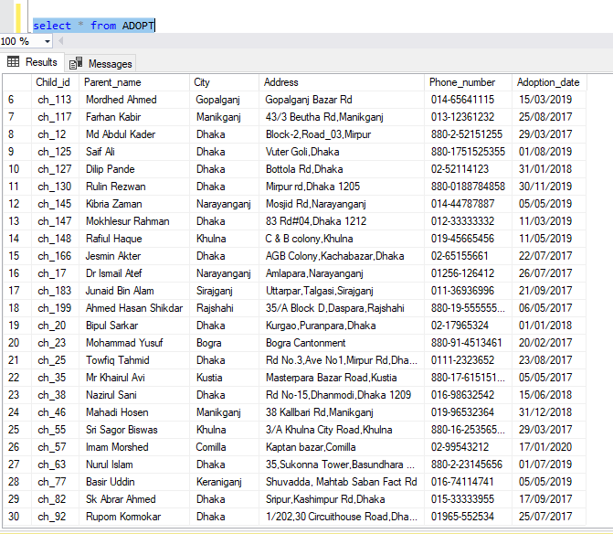1. ADOPT

2. ADVISOR

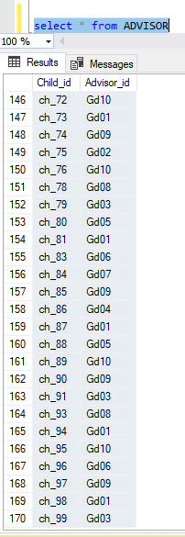

3. BUILDING

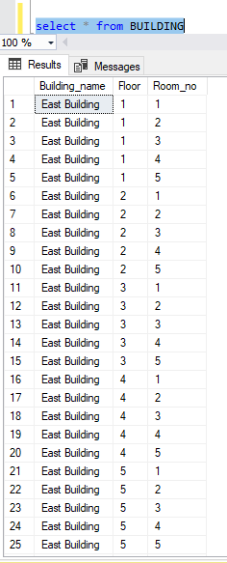

4. CHILD

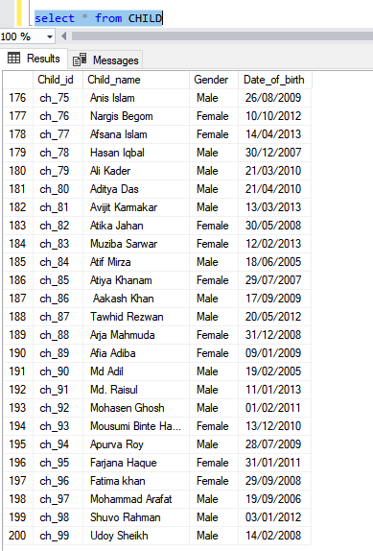

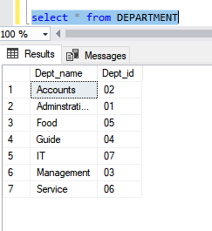5. DEPARTMENT

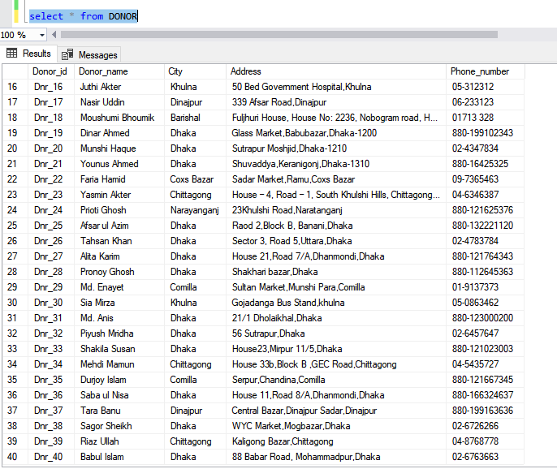6. DONAR

7. DONATION

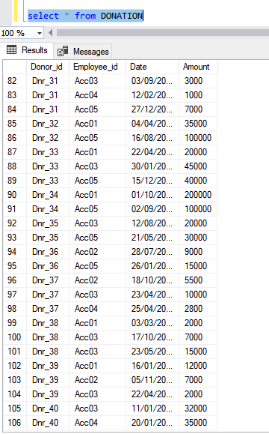

8. EMPLOYEE

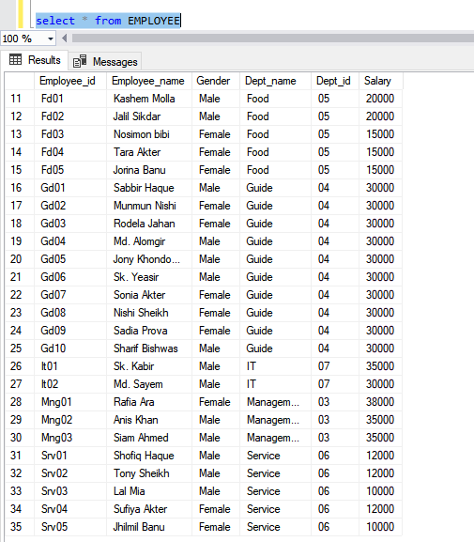

9. RESIDENT

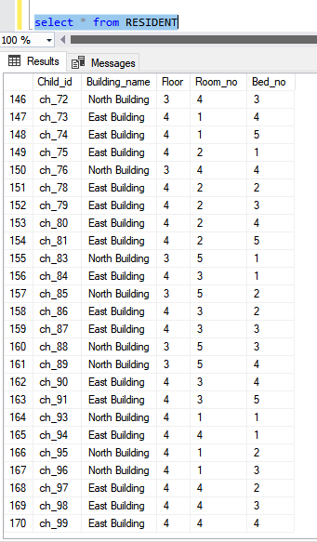

10. SCHOOL

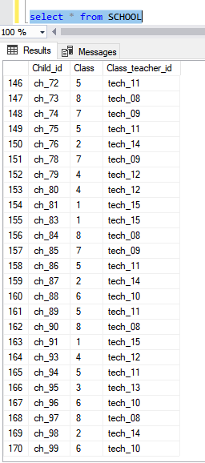

11. TEACHER

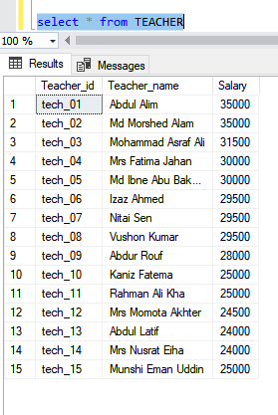

Appendix

create database Orphanage

use Orphanage

go

/* Tables */

create table CHILD

(

Child_id varchar(10) primary key,

Child_name varchar(30),

Gender varchar(8),

Date_of_birth varchar(15)

)

go

create table ADOPT

(

Child_id varchar(10),

Parent_name varchar(30),

City varchar(15),

Address varchar(100),

Phone_number varchar(16),

Adoption_date varchar(15)

constraint child_id_pk primary key(Child_id),

constraint child_id_fk foreign key(Child_id) references CHILD

)

go

create function dbo.CheckFunction(@Child_id varchar(20))/* Function */

returns int

as begin

IF EXISTS(SELECT 1 FROM ADOPT WITH(NOLOCK)

          WHERE Child_id = @Child_id)

return (select 1)

ELSE

return(select 0)

return -1

end/* Function */

go

create table DEPARTMENT

(

Dept_name nvarchar(20),

Dept_id varchar(10),

constraint dept_name_id_PK primary key (Dept_name,Dept_id)

)

go

create table EMPLOYEE

(

Employee_id varchar(10) primary key,

Employee_name nvarchar(30),

Gender varchar(8),

Dept_name nvarchar(20),

Dept_id varchar(10),

Salary int,

constraint dept_name_id_FK foreign key (Dept_name,Dept_id) references DEPARTMENT

)

go

create table ADVISOR

(

Child_id varchar(10) primary key,

Advisor_id varchar(10) not null,

foreign key(Child_id) references CHILD,

foreign key(Advisor_id) references EMPLOYEE,

check (dbo.CheckFunction(Child_id )=0),

check(Advisor_id like 'Gd%')

)

go

create table DONOR(

Donor_id varchar(10) primary key,

Donor_name nvarchar(30) ,

City nvarchar(15),

Address varchar(100),

Phone_number varchar(16) unique

)

go

create table DONATION(

Donor_id varchar(10) ,

Employee_id varchar(10),

Date varchar (16),

Amount int,

check(Employee_id like 'Acc%'),

primary key(Donor_id,Employee_id,Date),

foreign key(Donor_id) references DONOR,

foreign key(Employee_id) references EMPLOYEE

)

go

create table BUILDING(

Building_name varchar(20),

Floor tinyint,

Room_no tinyint,

Primary key(Building_name,Floor,Room_no)

)

go

create table RESIDENT(

Child_id varchar(10) unique,

Building_name varchar(20),

Floor tinyint,

Room_no tinyint,

Bed_no tinyint,

check (dbo.CheckFunction(Child_id )=0) ,

Primary key(Building_name,Floor,Room_no,bed_no),

foreign key(Child_id) references CHILD

)

go

create table TEACHER(

Teacher_id varchar(10),

Teacher_name nvarchar(30),

Salary int,

constraint teacher_id_PK primary key(Teacher_id)

)

go

create table SCHOOL(

Child_id varchar(10) primary key,

Class tinyint,

Class_teacher_id varchar(10),

check (dbo.CheckFunction(Child_id )=0) ,

check(class<=10),

foreign key(Child_id) references CHILD,

foreign key(Class_teacher_id) references TEACHER

)

go

/* Tables */

/*Values */

insert into DEPARTMENT

values

('Administration','01'),

('Accounts','02'),

('Management','03'),

('Guide','04'),

('Food','05'),

('Service','06'),

('IT','07')

go

insert into EMPLOYEE

values

('Admin01','Abdul Karim','Male','Administration','01','40000'),

('Admin02','Nusrat Jahan','Female','Administration','01','40000'),

('Admin03','Ankon Bishwas','Male','Administration','01','38000'),

('Admin04','Maimuna Akter','Female','Administration','01','38000'),

('Admin05','Md.Asif','Male','Administration','01','40000'),

('Acc01','Md. Rahim','Male','Accounts','02','35000'),

('Acc02','Nishat Ara','Female','Accounts','02','35000'),

('Acc03','Md. Ashfaq','Male','Accounts','02','32000'),

('Acc04','Nisho Rahman','Male','Accounts','02','30000'),

('Acc05','Kasfia Lucy','FeMale','Accounts','02','30000'),

('Mng01','Rafia Ara','Female','Management','03','38000'),

('Mng02','Anis Khan','Male','Management','03','35000'),

('Mng03','Siam Ahmed','Male','Management','03','35000'),

('Gd01','Sabbir Haque','Male','Guide','04','30000'),

('Gd02','Munmun Nishi','Female','Guide','04','30000'),

('Gd03','Rodela Jahan','Female','Guide','04','30000'),

('Gd04','Md. Alomgir','Male','Guide','04','30000'),

('Gd05','Jony Khondokar','Male','Guide','04','30000'),

('Gd06','Sk. Yeasir','Male','Guide','04','30000'),

('Gd07','Sonia Akter','Female','Guide','04','30000'),

('Gd08','Nishi Sheikh','Female','Guide','04','30000'),

('Gd09','Sadia Prova','Female','Guide','04','30000'),

('Gd10','Sharif Bishwas','Male','Guide','04','30000'),

('Fd01','Kashem Molla','Male','Food','05','20000'),

('Fd02','Jalil Sikdar','Male','Food','05','20000'),

('Fd03','Nosimon bibi','Female','Food','05','15000'),

('Fd04','Tara Akter','Female','Food','05','15000'),

('Fd05','Jorina Banu','Female','Food','05','15000'),

('Srv01','Shofiq Haque','Male','Service','06','12000'),

('Srv02','Tony Sheikh','Male','Service','06','12000'),

('Srv03','Lal Mia','Male','Service','06','10000'),

('Srv04','Sufiya Akter','Female','Service','06','12000'),

('Srv05','Jhilmil Banu','Female','Service','06','10000'),

('It01','Sk. Kabir','Male','IT','07','35000'),

('It02','Md. Sayem','Male','IT','07','30000')

go

insert into BUILDING

values

('East Building','1','1'),

('East Building','1','2'),

('East Building','1','3'),

('East Building','1','4'),

('East Building','1','5'),

('East Building','2','1'),

('East Building','2','2'),

('East Building','2','3'),

('East Building','2','4'),

('East Building','2','5'),

('East Building','3','1'),

('East Building','3','2'),

('East Building','3','3'),

('East Building','3','4'),

('East Building','3','5'),

('East Building','4','1'),

('East Building','4','2'),

('East Building','4','3'),

('East Building','4','4'),

('East Building','4','5'),

('East Building','5','1'),

('East Building','5','2'),

('East Building','5','3'),

('East Building','5','4'),

('East Building','5','5'),

('North Building','1','1'),

('North Building','1','2'),

('North Building','1','3'),

('North Building','1','4'),

('North Building','1','5'),

('North Building','2','1'),

('North Building','2','2'),

('North Building','2','3'),

('North Building','2','4'),

('North Building','2','5'),

('North Building','3','1'),

('North Building','3','2'),

('North Building','3','3'),

('North Building','3','4'),

('North Building','3','5'),

('North Building','4','1'),

('North Building','4','2'),

('North Building','4','3'),

('North Building','4','4'),

('North Building','4','5'),

('North Building','5','1'),

('North Building','5','2'),

('North Building','5','3'),

('North Building','5','4'),

('North Building','5','5')

go

insert into CHILD

values

('ch_01','Sabbir Ahmed','Male','12/01/2008'),

('ch_02','Barsha Akter','Female','16/04/2013'),

('ch_03','Rafi Rahman','Male','15/05/2011'),

('ch_04','Md. Anik ','Male','12/12/2007'),

('ch_05','Fariha Anjum','Female','03/02/2010'),

('ch_06','Md. Abir','Male','30/10/2012'),

('ch_07','Sadiya Akter','Female','16/04/2013'),

('ch_08','Palki Khatun ','Female','09/10/2009'),

('ch_09','Rodela Shaha','Female','10/10/2006'),

('ch_10','Siam Morshed','Male','11/01/2005'),

('ch_100','Aparna Ghosh','Female','12/12/2005'),

('ch_101','Babu Mia','Male','16/08/2013'),

('ch_102','Arpita Guho','Female','04/06/2010'),

('ch_103','Chinmoy Saha','Male','30/07/2011'),

('ch_104','Arij Sen','Male','10/07/2009'),

('ch_105','Hasnain Sarkar','Male','13/08/2008'),

('ch_106','Rudro Roy','Male','10/06/2006'),

('ch_107','Arafat Rahman','Male','16/12/2012'),

('ch_108','Sagorika Sen Gupta','Female','14/01/2008'),

('ch_109','Krinshna Das','Female','09/01/2009'),

('ch_11','Shofiqul Islam','Male','15/07/2013'),

('ch_110','Mahbuba Sultana','Female','15/01/2011'),

('ch_111','Hamid Khan','Male','14/06/2013'),

('ch_112','Kiraat Zaman','Female','14/05/2007'),

('ch_113','Hridoy Alam','Male','11/03/2006'),

('ch_114','Sabila Jahan','Female','11/08/2009'),

('ch_115','Ketu Mahbub','Male','02/08/2005'),

('ch_116','Binti Mahbuba','Female','12/05/2011'),

('ch_117','Iban Aziz','Male','15/10/2008'),

('ch_118','Sayma Akter','Female','15/01/2007'),

('ch_119','Shafiya Hasna','Female','29/03/2009'),

('ch_12','Chan Miah','Male','13/03/2005'),

('ch_120','Izaz Rahman','Male','23/04/2005'),

('ch_121','Eman Azim','Male','13/05/2013'),

('ch_122','Dhruba Pande','Male','15/07/2008'),

('ch_123','Dheeman Azim','Male','16/08/2008'),

('ch_124','Ashutosh Dev','Male','12/09/2009'),

('ch_125','Atia Adiba','Female','12/04/2013'),

('ch_126','Dhaval Karmakar','Male','16/12/2007'),

('ch_127','Arpit Sen','Male','19/02/2009'),

('ch_128','Rima Khondokar','Female','12/08/2006'),

('ch_129','Nawar Jannat','Female','14/10/2012'),

('ch_13','Anis Khan','Male','24/05/2005'),

('ch_130','Sajid Mosarraf','Female','12/08/2012'),

('ch_131','Misti Akter','Female','11/03/2013'),

('ch_132','Tania Haque','Female','29/01/2007'),

('ch_133','Amina Islam','Female','10/06/2012'),

('ch_134','Balraj Bhowmik','Male','14/10/2009'),

('ch_135','Ahraf Haque','Male','08/04/2012'),

('ch_136','Korobi Sultana','Female','17/01/2007'),

('ch_137','Muntaha Najim','Female','16/12/2005'),

('ch_138','Mohammad Sakil','Male','31/12/2011'),

('ch_139','Shanta Islam','Female','09/01/2009'),

('ch_14','Shurovi Khatun','Female','10/02/2013'),

('ch_140','Anik Das','Male','14/07/2009'),

('ch_141','Surma Amin','Female','09/01/2013'),

('ch_142','Nahida Sultana','Female','30/05/2011'),

('ch_143','Anik Kormokar','Male','08/11/2010'),

('ch_144','Mahera Mahbuba','Female','06/01/2009'),

('ch_145','Md Sultan Kadir','Male','08/12/2013'),

('ch_146','Abdul Halim ','Male','18/02/2007'),

('ch_147','Al Ameen','Male','15/07/2011'),

('ch_148','Shahida Banu','Female','07/11/2013'),

('ch_149','Shahinur Bipa','Female','15/06/2009'),

('ch_15','Saliha banu','Female','02/06/2012'),

('ch_150','Soumik Sen','Male','13/02/2012'),

('ch_151','Mukta Rayhana','Female','01/10/2011'),

('ch_152','Tasnim Salma','Female','06/09/2005'),

('ch_153','Fahim Nasir','Male','26/01/2009'),

('ch_154','Hasan Razi','Male','10/04/2011'),

('ch_155','Sadia Tasnim','Female','19/04/2007'),

('ch_156','Shahana Akter','Female','16/04/2009'),

('ch_157','Shammi Jahan','Female','15/10/2013'),

('ch_158','Golam Kibria','Male','16/06/2009'),

('ch_159','Shifat Alam','Male','07/06/2006'),

('ch_16','Tasfin haque ','Male','19/08/2008'),

('ch_160','Jabir Hasan','Male','23/01/2011'),

('ch_161','Elma Haque','Female','16/06/2011'),

('ch_162','Galib Azhar','Male','08/11/2005'),

('ch_163','Mamunur Rashid','Male','17/01/2009'),

('ch_164','Ayesha Jahan','Female','17/07/2011'),

('ch_165','Dabir Rayhan','Male','16/05/2005'),

('ch_166','Farah Jahan','Female','20/04/2007'),

('ch_167','Kaniz Fatema','Female','11/07/2010'),

('ch_168','Labib Ahmad','Male','22/03/2011'),

('ch_169','Liban Aiyub','Male','16/10/2005'),

('ch_17','Fahmida Fima','Female','20/09/2008'),

('ch_170','Nabil Islam','Male','21/09/2007'),

('ch_171','Hriddhi Sen','Male','09/10/2009'),

('ch_172','Surma Jahan','Female','05/09/2013'),

('ch_173','Naima Akter','Female','17/10/2007'),

('ch_174','Abhi kumar','Male','21/04/2008'),

('ch_175','Nishat Jahan Nishu','Female','29/01/2006'),

('ch_176','Fatema Tuz Zohura','Female','21/09/2012'),

('ch_177','Abir Rahman','Male','19/11/2012'),

('ch_178','Zisan Mollah','Male','17/08/2005'),

('ch_179','Abid Rayhan','Male','22/09/2008'),

('ch_18','Kalam Shah','Male','09/09/2006'),

('ch_180','Mostafa Kamal ','Male','19/02/2011'),

('ch_181','Rafid Hasan','Male','10/10/2005'),

('ch_182','Baha Ahmed','Female','04/08/2013'),

('ch_183','Bariyat Hasin','Female','21/12/2011'),

('ch_184','Danis Roy','Male','10/05/2009'),

('ch_185','Daliya Haque','Female','22/5/2007'),

('ch_186','Turjo Sen','Male','14/11/2011'),

('ch_187','Maliha Tasnim','Female','03/07/2013'),

('ch_188','Kiran Dutt','Male','07/07/2012'),

('ch_189','Rodela Jahan','Female','23/05/2012'),

('ch_19','Ashik khan','Male','25/10/2011'),

('ch_190','Rima Das','Female','20/02/2009'),

('ch_191','Khalil Akhtar Roni','Male','23/03/2008'),

('ch_192','Dibbo Roy Anupom','Male','02/06/2013'),

('ch_193','Jahan Talukdar','Male','05/05/2011'),

('ch_194','Jannat Hamida','Female','20/06/2009'),

('ch_195','Ripon Kumar','Male','23/06/2007'),

('ch_196','Lucky Islam','Female','11/07/2005'),

('ch_197','Mina Roy','Female','30/10/2008'),

('ch_198','Rema Sarkar','Female','14/11/2010'),

('ch_199','Md Sultan Mahmud','Male','10/03/2012'),

('ch_20','Amit Sana','Male','12/10/2006'),

('ch_200','Rafi Rayhan','Male','01/05/2013'),

('ch_21','Tanha Rifah','Female','05/10/2012'),

('ch_22','Titu Miah','Male','27/08/2011'),

('ch_23','Alom Khandakar','Male','15/07/2010'),

('ch_24','Ishika Eva','Female','14/12/2007'),

('ch_25','Shihab Uddin','Male','12/07/2007'),

('ch_26','Nobel Islam','Male','15/10/2010'),

('ch_27','Shourav Ghosh','Male','11/10/2009'),

('ch_28','Tazy Farzana','Female','16/04/2013'),

('ch_29','Thahira khatun','Female','22/02/2009'),

('ch_30','Rajib Hasan','Male','30/04/2013'),

('ch_31','Noor Nahar','Female','23/01/2013'),

('ch_32','Joshim Talukdar','Male','16/06/2010'),

('ch_33','Mohammad Ali','Male','13/05/2005'),

('ch_34',' Aaravi Islam','Female','25/07/2008'),

('ch_35','Abanti Haque','Female','15/08/2008'),

('ch_36','Arnab Bin Aziz','Male','25/11/2012'),

('ch_37','Fuad Sarkar','Male','13/09/2006'),

('ch_38','Samiur Rahman','Male','03/07/2011'),

('ch_39','Shifat Ali','Male','23/02/2009'),

('ch_40','Raisul kabir','Male','22/12/2013'),

('ch_41','Joynal Ali','Male','21/11/2013'),

('ch_42','Daisy Sarwar','Fermale','17/06/2010'),

('ch_43','Tarikul Islam','Male','26/06/2008'),

('ch_44','Jakia Sultana','Female','20/09/2013'),

('ch_45','Hamid Rahman','Male','27/10/2013'),

('ch_46','Zahid Ibne Morshed','Male','19/08/2013'),

('ch_47','Nadia Islam','Female','28/05/2011'),

('ch_48','Mohammad Antar','Male','16/06/2012'),

('ch_49','Arpan Pramanik','Male','15/09/2005'),

('ch_50','Nusrat Jahan','Female','24/03/2009'),

('ch_51','Mujibar Mia','Male','18/08/2013'),

('ch_52','Samira Tuba','Female','25/03/2012'),

('ch_53','Al Amin','Male','15/03/2012'),

('ch_54','Nahian Islam','Male','22/02/2007'),

('ch_55','Arpita Sen','Female','01/01/2005'),

('ch_56','Aburba Sen','Male','01/01/2005'),

('ch_57','Hamida Akter','Female','17/07/2013'),

('ch_58','Fazle Muzahid','Male','19/09/2007'),

('ch_59','Bevan Bhattacharya','Male','25/02/2009'),

('ch_60','Sharmin Koli','Female','19/04/2010'),

('ch_61','Moshumi Begum','Female','16/06/2013'),

('ch_62','Salma Fariha','Female','28/04/2007'),

('ch_63','Al Fahad Zoha','Male','16/05/2006'),

('ch_64','Muntaha Zaman','Female','29/05/2011'),

('ch_65','Nafisa Lubaba','Female','02/04/2011'),

('ch_66','Fahmida Nawar','Female','27/08/2005'),

('ch_67','Nesar Uddin','Male','05/02/2012'),

('ch_68','Md Anin Iqbal','Male','29/01/2008'),

('ch_69','Labiba Akter','Female','20/03/2010'),

('ch_70','Haris Kumar','Male','30/03/2011'),

('ch_71','Ria Sen','Female','15/05/2013'),

('ch_72','Rashid Maymuna','Female','26/05/2009'),

('ch_73','Asif Al Razi','Male','15/07/2005'),

('ch_74','Yafi Das','Male','29/07/2007'),

('ch_75','Anis Islam','Male','26/08/2009'),

('ch_76','Nargis Begom','Female','10/10/2012'),

('ch_77','Afsana Islam','Female','14/04/2013'),

('ch_78','Hasan Iqbal ','Male','30/12/2007'),

('ch_79','Ali Kader','Male','21/03/2010'),

('ch_80','Aditya Das','Male','21/04/2010'),

('ch_81','Avijit Karmakar','Male','13/03/2013'),

('ch_82','Atika Jahan','Female','30/05/2008'),

('ch_83','Muziba Sarwar','Female','12/02/2013'),

('ch_84','Atif Mirza','Male','18/06/2005'),

('ch_85','Atiya Khanam','Female','29/07/2007'),

('ch_86',' Aakash Khan','Male','17/09/2009'),

('ch_87','Tawhid Rezwan','Male','20/05/2012'),

('ch_88','Arja Mahmuda','Female','31/12/2008'),

('ch_89','Afia Adiba','Female','09/01/2009'),

('ch_90','Md Adil ','Male','19/02/2005'),

('ch_91','Md. Raisul','Male','11/01/2013'),

('ch_92','Mohasen Ghosh','Male','01/02/2011'),

('ch_93','Mousumi Binte Habib','Female','13/12/2010'),

('ch_94','Apurva Roy','Male','28/07/2009'),

('ch_95','Farjana Haque','Female','31/01/2011'),

('ch_96','Fatima khan','Female','29/09/2008'),

('ch_97','Mohammad Arafat','Male','19/09/2006'),

('ch_98','Shuvo Rahman','Male','03/01/2012'),

('ch_99','Udoy Sheikh','Male','14/02/2008')

go

insert into TEACHER

values

('tech_01','Abdul Alim','35000'),

('tech_02','Md Morshed Alam','35000'),

('tech_03','Mohammad Asraf Ali','31500'),

('tech_04','Mrs Fatima Jahan','30000'),

('tech_05','Md Ibne Abu Bakkar','30000'),

('tech_06','Izaz Ahmed','29500'),

('tech_07','Nitai Sen','29500'),

('tech_08','Vushon Kumar','29500'),

('tech_09','Abdur Rouf','28000'),

('tech_10','Kaniz Fatema','25000'),

('tech_11','Rahman Ali Kha','25000'),

('tech_12','Mrs Momota Akhter','24500'),

('tech_13','Abdul Latif','24000'),

('tech_14','Mrs Nusrat Eiha','24000'),

('tech_15','Munshi Eman Uddin','25000')

insert into DONOR

values

('Dnr_01','Abdul Bari','Dhaka','476/c, d.i.t. Road , Malibagh, Dhala-1217',' 02-9338833'),

('Dnr_02','Tushar Ahmed','Dhaka','10, Kawran Bazar, Jahangir Tower, Dhaka-1215','880-171349867'),

('Dnr_03','Meghna Chowdhury','Dhaka','House # 15-16, Road # 113/a, Gulshan 2, Dhka-1212','02-9862594'),

('Dnr_04','Ali Ahmed','Sylhet','Jalalabad Ragib Rabeya Medical College, Sylhet-3100','880-181002901'),

('Dnr_05','Md. Ismail','Dhaka',' Room # 118, Supreme Court Bar Association Building, Dhaka-1000','02-9120486'),

('Dnr_06','Ronjon Bishws','Chittagong','Jiban Bima Bhaban 56, Agrabad C/A, Chittagong','88-031-81219'),

('Dnr_07','Nusrat Fiha','Khulna','A-33, K.d.a. Avenue, Khulna','880-41-72163'),

('Dnr_08','Anisur Rahman','Dhaka','53/1, johnson road, dhaka national medical college & hospital, Dhaka-1100','02 7514533'),

('Dnr_09','Karim Bhuiyan','Chittagong','291 Layel Road, Laldighi West, Chittagong','880-31-61843'),

('Dnr_10','Omar Khan','Sylhet','Mazar Road,Sylhet-3110','880-1619010200'),

('Dnr_11','Milisha Borman','Dhaka','Block-d, Section-6, Pallabi (mirpur), Dhaka-1218','02-9013907'),

('Dnr_12','Sayed Ali','Khulna','United Jute Press, D.c. Road, Ralgate Daulatpur,Khulna','880-41-7746'),

('Dnr_13',' Amin Ahmed','Narayanganj','72, Nayamati, Narayanganj','03-7672380'),

('Dnr_14','Nuzhat Nishi','Dhaka','13/2 Block C, Tajmahal Road, Mohammadpur','02-9127282'),

('Dnr_15','Mushfiqur Islam','Comilla','Comilla University Road, Comilla ','880-121033210'),

('Dnr_16','Juthi Akter','Khulna','50 Bed Government Hospital,Khulna ','05-312312'),

('Dnr_17','Nasir Uddin','Dinajpur','339 Afsar Road,Dinajpur','06-233123'),

('Dnr_18','Moushumi Bhoumik','Barishal','Fuljhuri House, House No: 2236, Nobogram road, Hatem Ali Chowrasta, Barisal','01713 328'),

('Dnr_19','Dinar Ahmed','Dhaka','Glass Market,Babubazar,Dhaka-1200','880-199102343'),

('Dnr_20','Munshi Haque','Dhaka','Sutrapur Moshjid,Dhaka-1210','02-4347834'),

('Dnr_21','Younus Ahmed ','Dhaka','Shuvaddya,Keranigonj,Dhaka-1310','880-16425325'),

('Dnr_22','Faria Hamid','Coxs Bazar','Sadar Market,Ramu,Coxs Bazar','09-7365463'),

('Dnr_23','Yasmin Akter','Chittagong','House – 4, Road – 1, South Khulshi Hills, Chittagong, Bangladesh','04-6346387'),

('Dnr_24','Prioti Ghosh','Narayanganj','23Khulshi Road,Naratanganj','880-121625376'),

('Dnr_25','Afsar ul Azim','Dhaka','Raod 2,Block B, Banani,Dhaka','880-132221120'),

('Dnr_26','Tahsan Khan','Dhaka','Sector 3, Road 5,Uttara,Dhaka','02-4783784'),

('Dnr_27','Alita Karim','Dhaka','House 21,Road 7/A,Dhanmondi,Dhaka','880-121764343'),

('Dnr_28','Pronoy Ghosh','Dhaka','Shakhari bazar,Dhaka','880-112645363'),

('Dnr_29','Md. Enayet','Comilla','Sultan Market,Munshi Para,Comilla','01-9137373'),

('Dnr_30','Sia Mirza','Khulna','Gojadanga Bus Stand,khulna','05-0863462'),

('Dnr_31','Md. Anis','Dhaka','21/1 Dholaikhal,Dhaka','880-123000200'),

('Dnr_32','Piyush Mridha','Dhaka','56 Sutrapur,Dhaka','02-6457647'),

('Dnr_33','Shakila Susan','Dhaka','House23,Mirpur 11/5,Dhaka ','880-121023003'),

('Dnr_34','Mehdi Mamun','Chittagong','House 33b,Block B ,GEC Road,Chittagong','04-5435727'),

('Dnr_35','Durjoy Islam','Comilla','Serpur,Chandina,Comilla','880-121667345'),

('Dnr_36','Saba ul Nisa','Dhaka','House 11,Road 8/A,Dhanmondi,Dhaka','880-166324637'),

('Dnr_37','Tara Banu','Dinajpur','Central Bazar,Dinajpur Sadar,Dinajpur','880-199163636'),

('Dnr_38','Sagor Sheikh','Dhaka','WYC Market,Mogbazar,Dhaka','02-6726266'),

('Dnr_39','Riaz Ullah','Chittagong','Kaligong Bazar,Chittagong','04-8768778'),

('Dnr_40','Babul Islam','Dhaka','88 Babar Road, Mohammadpur,Dhaka','02-6763663')

go

insert into DONATION

values

('Dnr_01','Acc01','05/01/2019','30000'),

('Dnr_01','Acc05','25/02/2019','25000'),

('Dnr_02','Acc02','18/07/2017','5000'),

('Dnr_02','Acc03','08/01/2018','40000'),

('Dnr_01','Acc04','20/01/2020','16000'),

('Dnr_03','Acc01','18/02/2019','3000'),

('Dnr_02','Acc05','03/01/2019','42000'),

('Dnr_03','Acc01','15/07/2019','10000'),

('Dnr_04','Acc05','12/12/2018','50000'),

('Dnr_40','Acc03','11/01/2017','32000'),

('Dnr_04','Acc02','02/06/2019','10000'),

('Dnr_40','Acc04','20/01/2020','35000'),

('Dnr_04','Acc01','12/10/2019','25000'),

('Dnr_39','Acc03','22/04/2019','2000'),

('Dnr_39','Acc02','05/11/2019','7000'),

('Dnr_39','Acc01','16/01/2020','12000'),

('Dnr_05','Acc02','29/03/2017','75000'),

('Dnr_05','Acc04','01/05/2018','15000'),

('Dnr_05','Acc01','05/01/2019','300000'),

('Dnr_38','Acc01','03/03/2017','2000'),

('Dnr_38','Acc03','17/10/2017','7000'),

('Dnr_38','Acc03','23/05/2019','15000'),

('Dnr_36','Acc02','28/07/2019','9000'),

('Dnr_36','Acc05','26/01/2020','15000'),

('Dnr_06','Acc04','12/06/2017','21000'),

('Dnr_06','Acc01','30/01/2018','15000'),

('Dnr_06','Acc01','26/03/2019','5000'),

('Dnr_37','Acc04','25/04/2017','2800'),

('Dnr_37','Acc02','18/10/2018','5500'),

('Dnr_37','Acc03','23/04/2019','10000'),

('Dnr_07','Acc05','07/07/2019','7000'),

('Dnr_07','Acc02','01/01/2020','9500'),

('Dnr_35','Acc05','21/05/2019','30000'),

('Dnr_35','Acc03','12/08/2019','20000'),

('Dnr_08','Acc03','23/05/2018','35000'),

('Dnr_08','Acc02','07/03/2019','40000'),

('Dnr_08','Acc04','12/07/2019','5000'),

('Dnr_34','Acc01','01/10/2017','200000'),

('Dnr_34','Acc05','02/09/2019','100000'),

('Dnr_09','Acc02','28/02/2017','4000'),

('Dnr_09','Acc04','10/09/2018','5000'),

('Dnr_09','Acc03','26/11/2019','9000'),

('Dnr_33','Acc05','15/12/2017','40000'),

('Dnr_33','Acc01','22/04/2018','20000'),

('Dnr_33','Acc03','30/01/2019','45000'),

('Dnr_10','Acc02','19/09/2017','2000'),

('Dnr_10','Acc01','22/09/2018','5000'),

('Dnr_10','Acc04','04/11/2019','8000'),

('Dnr_32','Acc01','04/04/2017','35000'),

('Dnr_32','Acc05','16/08/2019','100000'),

('Dnr_11','Acc02','24/03/2017','3000'),

('Dnr_11','Acc03','05/01/2018','7500'),

('Dnr_11','Acc01','30/07/2019','15000'),

('Dnr_31','Acc04','12/02/2017','1000'),

('Dnr_31','Acc03','03/09/2018','3000'),

('Dnr_31','Acc05','27/12/2019','7000'),

('Dnr_12','Acc02','15/06/2017','12000'),

('Dnr_12','Acc01','28/05/2018','18000'),

('Dnr_12','Acc04','08/10/2019','22000'),

('Dnr_30','Acc05','20/01/2017','2000'),

('Dnr_30','Acc03','05/11/2018','5000'),

('Dnr_30','Acc02','19/07/2019','10000'),

('Dnr_13','Acc05','12/12/2017','150000'),

('Dnr_13','Acc04','23/01/2019','170000'),

('Dnr_29','Acc01','01/08/2017','1000'),

('Dnr_29','Acc05','06/03/2018','500'),

('Dnr_29','Acc03','30/06/2019','7000'),

('Dnr_14','Acc01','28/07/2018','2000'),

('Dnr_14','Acc02','03/11/2019','5000'),

('Dnr_28','Acc02','01/12/2017','10000'),

('Dnr_28','Acc04','18/01/2019','40000'),

('Dnr_27','Acc05','12/01/2017','100000'),

('Dnr_27','Acc01','01/07/2018','120000'),

('Dnr_26','Acc03','31/01/2017','13000'),

('Dnr_26','Acc01','07/11/2018','17500'),

('Dnr_26','Acc04','15/05/2019','20000'),

('Dnr_15','Acc02','23/09/2017','1000'),

('Dnr_15','Acc05','03/01/2019','1000'),

('Dnr_16','Acc03','22/04/2017','30000'),

('Dnr_16','Acc01','06/12/2019','35000'),

('Dnr_25','Acc04','30/11/2018','60000'),

('Dnr_25','Acc02','10/10/2019','80000'),

('Dnr_20','Acc01','16/04/2017','250000'),

('Dnr_20','Acc05','07/01/2018','50000'),

('Dnr_20','Acc04','20/07/2019','100000'),

('Dnr_17','Acc03','11/09/2017','6000'),

('Dnr_17','Acc05','24/05/2018','5000'),

('Dnr_17','Acc02','01/02/2019','10000'),

('Dnr_24','Acc01','13/11/2017','20000'),

('Dnr_24','Acc03','04/03/2018','20000'),

('Dnr_24','Acc02','29/05/2019','40000'),

('Dnr_18','Acc05','25/12/2017','3200'),

('Dnr_18','Acc03','21/06/2018','5300'),

('Dnr_18','Acc04','31/01/2019','5000'),

('Dnr_23','Acc05','03/09/2017','70000'),

('Dnr_23','Acc05','23/07/2018','75000'),

('Dnr_23','Acc01','23/12/2019','50000'),

('Dnr_22','Acc02','11/05/2017','15000'),

('Dnr_22','Acc05','25/08/2018','17000'),

('Dnr_22','Acc03','02/04/2019','20000'),

('Dnr_19','Acc01','19/10/2017','22000'),

('Dnr_19','Acc03','02/07/2018','15000'),

('Dnr_19','Acc02','15/03/2019','30000'),

('Dnr_21','Acc05','12/09/2017','10000'),

('Dnr_21','Acc04','31/03/2018','30000'),

('Dnr_21','Acc03','22/12/2019','40000')

insert into ADOPT

values

('ch_01','Mr Kamal Hasan','Dhaka','13/a Hajipara,Mogbazar','880-2-24675655','15/01/2017'),

('ch_111','Dr Abul Hasnat','Dhaka','Joynag Road,Baksibazar','880-2-53246246','20/02/2017'),

('ch_12','Md Abdul Kader','Dhaka','Block-2,Road_03,Mirpur','880-2-52151255','29/03/2017'),

('ch_23','Mohammad Yusuf','Bogra','Bogra Cantonment','880-91-4513461','20/02/2017'),

('ch_55','Sri Sagor Biswas','Khulna','3/A Khulna City Road,Khulna','880-16-25356522','29/03/2017'),

('ch_35','Mr Khairul Avi','Kustia','Masterpara Bazar Road,Kustia','880-17-61515111','05/05/2017'),

('ch_199','Ahmed Hasan Shikdar','Rajshahi','35/A Block D,Daspara,Rajshahi','880-19-55555555','06/05/2017'),

('ch_166','Jesmin Akter','Dhaka','AGB Colony,Kachabazar,Dhaka','02-65155661','22/07/2017'),

('ch_92','Rupom Kormokar','Dhaka','1/202,30 Circuithouse Road,Dhaka-1205','01965-552534','25/07/2017'),

('ch_17','Dr Ismail Atef','Narayanganj','Amlapara,Narayanganj','01256-126412','26/07/2017'),

('ch_25','Towfiq Tahmid','Dhaka','Rd No.3,Ave No1,Mirpur Rd,Dhaka','0111-2323652','23/08/2017'),

('ch_117','Farhan Kabir','Manikganj','43/3 Beutha Rd,Manikganj','013-12361232','25/08/2017'),

('ch_82','Sk Abrar Ahmed','Dhaka','Sripur,Kashimpur Rd,Dhaka','015-33333955','17/09/2017'),

('ch_183','Junaid Bin Alam','Sirajganj','Uttarpar,Talgasi,Sirajganj','011-36936996','21/09/2017'),

('ch_05','Mitul Sarkar','Comilla','2/G Bhuiyan Bari,Comilla','014-12336456','01/10/2017'),

('ch_20','Bipul Sarkar','Dhaka','Kurgao,Puranpara,Dhaka','02-17965324','01/01/2018'),

('ch_127','Dilip Pande','Dhaka','Bottola Rd,Dhaka','02-52114123','31/01/2018'),

('ch_103','Dr Bisnu Sarkar','Shylhet','25/5 New Market Rd,Shylhet','016-66666356','08/06/2018'),

('ch_38','Nazirul Sani','Dhaka','Rd No-15,Dhanmodi,Dhaka 1209','016-98632542','15/06/2018'),

('ch_46','Mahadi Hosen','Manikganj','38 Kallbari Rd,Manikganj','019-96532364','31/12/2018'),

('ch_145','Kibria Zaman','Narayanganj','Mosjid Rd,Narayanganj','014-44787887','05/05/2019'),

('ch_108','Sourav Pal','Bogra','7/A Satmatha,Bogra','019-99999656','05/02/2019'),

('ch_147','Mokhlesur Rahman','Dhaka','83 Rd#04,Dhaka 1212','012-33333332','11/03/2019'),

('ch_113','Mordhed Ahmed','Gopalganj','Gopalganj Bazar Rd','014-65641115','15/03/2019'),

('ch_148','Rafiul Haque','Khulna','C & B colony,Khulna','019-45665456','11/05/2019'),

('ch_77','Basir Uddin','Keraniganj','Shuvadda, Mahtab Saban Fact Rd','016-74114741','05/05/2019'),

('ch_63','Nurul Islam','Dhaka','35,Sukonna Tower,Basundhara Goli','880-2-23145656','01/07/2019'),

('ch_125','Saif Ali','Dhaka','Vuter Goli,Dhaka','880-1751525355','01/08/2019'),

('ch_130','Rulin Rezwan','Dhaka','Mirpur rd,Dhaka 1205','880-0188784858','30/11/2019'),

('ch_57','Imam Morshed','Comilla','Kaptan bazar,Comilla','02-99543212', '17/01/2020')

go

insert into ADVISOR

values

('ch_02','Gd01'),

('ch_03','Gd03'),

('ch_04','Gd08'),

('ch_06','Gd04'),

('ch_07','Gd08'),

('ch_08','Gd09'),

('ch_09','Gd05'),

('ch_10','Gd10'),

('ch_11','Gd07'),

('ch_13','Gd04'),

('ch_14','Gd06'),

('ch_15','Gd01'),

('ch_16','Gd05'),

('ch_18','Gd08'),

('ch_19','Gd02'),

('ch_21','Gd07'),

('ch_22','Gd09'),

('ch_24','Gd03'),

('ch_26','Gd08'),

('ch_27','Gd01'),

('ch_28','Gd04'),

('ch_29','Gd07'),

('ch_30','Gd06'),

('ch_31','Gd10'),

('ch_32','Gd05'),

('ch_33','Gd02'),

('ch_34','Gd04'),

('ch_36','Gd07'),

('ch_37','Gd09'),

('ch_39','Gd08'),

('ch_40','Gd02'),

('ch_41','Gd05'),

('ch_42','Gd10'),

('ch_43','Gd03'),

('ch_44','Gd06'),

('ch_45','Gd04'),

('ch_47','Gd07'),

('ch_48','Gd01'),

('ch_49','Gd05'),

('ch_50','Gd09'),

('ch_51','Gd10'),

('ch_52','Gd04'),

('ch_53','Gd07'),

('ch_54','Gd03'),

('ch_56','Gd10'),

('ch_58','Gd08'),

('ch_59','Gd05'),

('ch_60','Gd09'),

('ch_61','Gd01'),

('ch_62','Gd06'),

('ch_64','Gd02'),

('ch_65','Gd07'),

('ch_66','Gd10'),

('ch_67','Gd09'),

('ch_68','Gd03'),

('ch_69','Gd01'),

('ch_70','Gd04'),

('ch_71','Gd05'),

('ch_72','Gd10'),

('ch_73','Gd01'),

('ch_74','Gd09'),

('ch_75','Gd02'),

('ch_76','Gd10'),

('ch_78','Gd08'),

('ch_79','Gd03'),

('ch_80','Gd05'),

('ch_81','Gd01'),

('ch_83','Gd06'),

('ch_84','Gd07'),

('ch_85','Gd09'),

('ch_86','Gd04'),

('ch_87','Gd01'),

('ch_88','Gd05'),

('ch_89','Gd10'),

('ch_90','Gd09'),

('ch_91','Gd03'),

('ch_93','Gd08'),

('ch_94','Gd01'),

('ch_95','Gd10'),

('ch_96','Gd06'),

('ch_97','Gd09'),

('ch_98','Gd01'),

('ch_99','Gd03'),

('ch_100','Gd05'),

('ch_101','Gd07'),

('ch_102','Gd06'),

('ch_104','Gd02'),

('ch_105','Gd04'),

('ch_106','Gd10'),

('ch_107','Gd09'),

('ch_109','Gd03'),

('ch_110','Gd05'),

('ch_112','Gd08'),

('ch_114','Gd01'),

('ch_115','Gd07'),

('ch_116','Gd06'),

('ch_118','Gd09'),

('ch_119','Gd03'),

('ch_120','Gd04'),

('ch_121','Gd05'),

('ch_122','Gd02'),

('ch_123','Gd09'),

('ch_124','Gd06'),

('ch_126','Gd08'),

('ch_128','Gd07'),

('ch_129','Gd05'),

('ch_131','Gd03'),

('ch_132','Gd09'),

('ch_133','Gd06'),

('ch_134','Gd01'),

('ch_135','Gd04'),

('ch_136','Gd08'),

('ch_137','Gd07'),

('ch_138','Gd02'),

('ch_139','Gd05'),

('ch_140','Gd09'),

('ch_141','Gd06'),

('ch_142','Gd01'),

('ch_143','Gd03'),

('ch_144','Gd04'),

('ch_146','Gd08'),

('ch_149','Gd10'),

('ch_150','Gd02'),

('ch_151','Gd05'),

('ch_152','Gd10'),

('ch_153','Gd03'),

('ch_154','Gd06'),

('ch_155','Gd04'),

('ch_156','Gd01'),

('ch_157','Gd05'),

('ch_158','Gd01'),

('ch_159','Gd02'),

('ch_160','Gd02'),

('ch_161','Gd07'),

('ch_162','Gd06'),

('ch_163','Gd08'),

('ch_164','Gd03'),

('ch_165','Gd04'),

('ch_167','Gd09'),

('ch_168','Gd08'),

('ch_169','Gd05'),

('ch_170','Gd02'),

('ch_171','Gd04'),

('ch_172','Gd07'),

('ch_173','Gd10'),

('ch_174','Gd10'),

('ch_175','Gd01'),

('ch_176','Gd02'),

('ch_177','Gd03'),

('ch_178','Gd06'),

('ch_179','Gd08'),

('ch_180','Gd07'),

('ch_181','Gd09'),

('ch_182','Gd02'),

('ch_184','Gd10'),

('ch_185','Gd06'),

('ch_186','Gd04'),

('ch_187','Gd02'),

('ch_188','Gd07'),

('ch_189','Gd08'),

('ch_190','Gd03'),

('ch_191','Gd10'),

('ch_192','Gd06'),

('ch_193','Gd02'),

('ch_194','Gd08'),

('ch_195','Gd07'),

('ch_196','Gd03'),

('ch_197','Gd06'),

('ch_198','Gd04'),

('ch_200','Gd02')

insert into RESIDENT

values

('ch_03','East Building','1','1','1'),

('ch_04','East Building','1','1','2'),

('ch_06','East Building','1','1','3'),

('ch_10','East Building','1','1','4'),

('ch_101','East Building','1','1','5'),

('ch_104','East Building','1','2','1'),

('ch_105','East Building','1','2','2'),

('ch_106','East Building','1','2','3'),

('ch_107','East Building','1','2','4'),

('ch_11','East Building','1','2','5'),

('ch_115','East Building','1','3','1'),

('ch_120','East Building','1','3','2'),

('ch_121','East Building','1','3','3'),

('ch_122','East Building','1','3','4'),

('ch_123','East Building','1','3','5'),

('ch_124','East Building','1','4','1'),

('ch_126','East Building','1','4','2'),

('ch_13','East Building','1','4','3'),

('ch_134','East Building','1','4','4'),

('ch_135','East Building','1','4','5'),

('ch_138','East Building','1','5','1'),

('ch_140','East Building','1','5','2'),

('ch_143','East Building','1','5','3'),

('ch_146','East Building','1','5','4'),

('ch_150','East Building','1','5','5'),

('ch_153','East Building','2','1','1'),

('ch_154','East Building','2','1','2'),

('ch_158','East Building','2','1','3'),

('ch_159','East Building','2','1','4'),

('ch_16','East Building','2','1','5'),

('ch_160','East Building','2','2','1'),

('ch_162','East Building','2','2','2'),

('ch_163','East Building','2','2','3'),

('ch_165','East Building','2','2','4'),

('ch_168','East Building','2','2','5'),

('ch_169','East Building','2','3','1'),

('ch_170','East Building','2','3','2'),

('ch_171','East Building','2','3','3'),

('ch_174','East Building','2','3','4'),

('ch_177','East Building','2','3','5'),

('ch_178','East Building','2','4','1'),

('ch_179','East Building','2','4','2'),

('ch_18','East Building','2','4','3'),

('ch_180','East Building','2','4','4'),

('ch_181','East Building','2','4','5'),

('ch_184','East Building','2','5','1'),

('ch_186','East Building','2','5','2'),

('ch_188','East Building','2','5','3'),

('ch_19','East Building','2','5','4'),

('ch_191','East Building','2','5','5'),

('ch_192','East Building','3','1','1'),

('ch_193','East Building','3','1','2'),

('ch_195','East Building','3','1','3'),

('ch_200','East Building','3','1','4'),

('ch_22','East Building','3','1','5'),

('ch_26','East Building','3','2','1'),

('ch_27','East Building','3','2','2'),

('ch_30','East Building','3','2','3'),

('ch_32','East Building','3','2','4'),

('ch_33','East Building','3','2','5'),

('ch_36','East Building','3','3','1'),

('ch_37','East Building','3','3','2'),

('ch_39','East Building','3','3','3'),

('ch_40','East Building','3','3','4'),

('ch_41','East Building','3','3','5'),

('ch_43','East Building','3','4','1'),

('ch_45','East Building','3','4','2'),

('ch_48','East Building','3','4','3'),

('ch_49','East Building','3','4','4'),

('ch_51','East Building','3','4','5'),

('ch_53','East Building','3','5','1'),

('ch_54','East Building','3','5','2'),

('ch_56','East Building','3','5','3'),

('ch_58','East Building','3','5','4'),

('ch_59','East Building','3','5','5'),

('ch_67','East Building','4','1','1'),

('ch_68','East Building','4','1','2'),

('ch_70','East Building','4','1','3'),

('ch_73','East Building','4','1','4'),

('ch_74','East Building','4','1','5'),

('ch_75','East Building','4','2','1'),

('ch_78','East Building','4','2','2'),

('ch_79','East Building','4','2','3'),

('ch_80','East Building','4','2','4'),

('ch_81','East Building','4','2','5'),

('ch_84','East Building','4','3','1'),

('ch_86','East Building','4','3','2'),

('ch_87','East Building','4','3','3'),

('ch_90','East Building','4','3','4'),

('ch_91','East Building','4','3','5'),

('ch_94','East Building','4','4','1'),

('ch_97','East Building','4','4','2'),

('ch_98','East Building','4','4','3'),

('ch_99','East Building','4','4','4'),

('ch_02','North Building','1','1','1'),

('ch_07','North Building','1','1','2'),

('ch_08','North Building','1','1','3'),

('ch_09','North Building','1','1','4'),

('ch_100','North Building','1','1','5'),

('ch_102','North Building','1','2','1'),

('ch_109','North Building','1','2','2'),

('ch_110','North Building','1','2','3'),

('ch_112','North Building','1','2','4'),

('ch_114','North Building','1','2','5'),

('ch_116','North Building','1','3','1'),

('ch_118','North Building','1','3','2'),

('ch_119','North Building','1','3','3'),

('ch_128','North Building','1','3','4'),

('ch_129','North Building','1','3','5'),

('ch_131','North Building','1','4','1'),

('ch_132','North Building','1','4','2'),

('ch_133','North Building','1','4','3'),

('ch_136','North Building','1','4','4'),

('ch_137','North Building','1','4','5'),

('ch_139','North Building','1','5','1'),

('ch_14','North Building','1','5','2'),

('ch_141','North Building','1','5','3'),

('ch_142','North Building','1','5','4'),

('ch_144','North Building','1','5','5'),

('ch_149','North Building','2','1','1'),

('ch_15','North Building','2','1','2'),

('ch_151','North Building','2','1','3'),

('ch_152','North Building','2','1','4'),

('ch_155','North Building','2','1','5'),

('ch_156','North Building','2','2','1'),

('ch_157','North Building','2','2','2'),

('ch_161','North Building','2','2','3'),

('ch_164','North Building','2','2','4'),

('ch_167','North Building','2','2','5'),

('ch_172','North Building','2','3','1'),

('ch_173','North Building','2','3','2'),

('ch_175','North Building','2','3','3'),

('ch_176','North Building','2','3','4'),

('ch_182','North Building','2','3','5'),

('ch_185','North Building','2','4','1'),

('ch_187','North Building','2','4','2'),

('ch_189','North Building','2','4','3'),

('ch_190','North Building','2','4','4'),

('ch_194','North Building','2','4','5'),

('ch_196','North Building','2','5','1'),

('ch_197','North Building','2','5','2'),

('ch_198','North Building','2','5','3'),

('ch_21','North Building','2','5','4'),

('ch_24','North Building','2','5','5'),

('ch_28','North Building','3','1','1'),

('ch_29','North Building','3','1','2'),

('ch_31','North Building','3','1','3'),

('ch_34','North Building','3','1','4'),

('ch_42','North Building','3','1','5'),

('ch_44','North Building','3','2','1'),

('ch_47','North Building','3','2','2'),

('ch_50','North Building','3','2','3'),

('ch_52','North Building','3','2','4'),

('ch_60','North Building','3','2','5'),

('ch_61','North Building','3','3','1'),

('ch_62','North Building','3','3','2'),

('ch_64','North Building','3','3','3'),

('ch_65','North Building','3','3','4'),

('ch_66','North Building','3','3','5'),

('ch_69','North Building','3','4','1'),

('ch_71','North Building','3','4','2'),

('ch_72','North Building','3','4','3'),

('ch_76','North Building','3','4','4'),

('ch_83','North Building','3','5','1'),

('ch_85','North Building','3','5','2'),

('ch_88','North Building','3','5','3'),

('ch_89','North Building','3','5','4'),

('ch_93','North Building','4','1','1'),

('ch_95','North Building','4','1','2'),

('ch_96','North Building','4','1','3')

insert into SCHOOL

values

('ch_02','1','tech_15'),

('ch_03','3','tech_13'),

('ch_04','7','tech_09'),

('ch_06','2','tech_14'),

('ch_07','1','tech_15'),

('ch_08','2','tech_14'),

('ch_09','8','tech_08'),

('ch_10','8','tech_08'),

('ch_11','1','tech_15'),

('ch_13','8','tech_08'),

('ch_14','1','tech_15'),

('ch_15','2','tech_14'),

('ch_16','6','tech_10'),

('ch_18','8','tech_08'),

('ch_19','3','tech_13'),

('ch_21','2','tech_14'),

('ch_22','3','tech_13'),

('ch_24','7','tech_09'),

('ch_26','4','tech_12'),

('ch_27','5','tech_11'),

('ch_28','1','tech_15'),

('ch_29','5','tech_11'),

('ch_30','1','tech_15'),

('ch_31','1','tech_15'),

('ch_32','4','tech_12'),

('ch_33','8','tech_08'),

('ch_34','6','tech_10'),

('ch_36','2','tech_14'),

('ch_37','8','tech_08'),

('ch_39','5','tech_11'),

('ch_40','1','tech_15'),

('ch_41','1','tech_15'),

('ch_42','4','tech_12'),

('ch_43','6','tech_10'),

('ch_44','1','tech_15'),

('ch_45','1','tech_15'),

('ch_47','3','tech_13'),

('ch_48','2','tech_14'),

('ch_49','8','tech_08'),

('ch_50','5','tech_11'),

('ch_51','1','tech_15'),

('ch_52','2','tech_14'),

('ch_53','2','tech_14'),

('ch_54','7','tech_09'),

('ch_56','8','tech_08'),

('ch_58','7','tech_09'),

('ch_59','5','tech_11'),

('ch_60','4','tech_12'),

('ch_61','1','tech_15'),

('ch_62','7','tech_09'),

('ch_64','3','tech_13'),

('ch_65','3','tech_13'),

('ch_66','8','tech_08'),

('ch_67','2','tech_14'),

('ch_68','6','tech_10'),

('ch_69','4','tech_12'),

('ch_70','3','tech_13'),

('ch_71','1','tech_15'),

('ch_72','5','tech_11'),

('ch_73','8','tech_08'),

('ch_74','7','tech_09'),

('ch_75','5','tech_11'),

('ch_76','2','tech_14'),

('ch_78','7','tech_09'),

('ch_79','4','tech_12'),

('ch_80','4','tech_12'),

('ch_81','1','tech_15'),

('ch_83','1','tech_15'),

('ch_84','8','tech_08'),

('ch_85','7','tech_09'),

('ch_86','5','tech_11'),

('ch_87','2','tech_14'),

('ch_88','6','tech_10'),

('ch_89','5','tech_11'),

('ch_90','8','tech_08'),

('ch_91','1','tech_15'),

('ch_93','4','tech_12'),

('ch_94','5','tech_11'),

('ch_95','3','tech_13'),

('ch_96','6','tech_10'),

('ch_97','8','tech_08'),

('ch_98','2','tech_14'),

('ch_99','6','tech_10'),

('ch_100','8','tech_08'),

('ch_101','1','tech_15'),

('ch_102','4','tech_12'),

('ch_104','5','tech_11'),

('ch_105','6','tech_10'),

('ch_106','8','tech_08'),

('ch_107','2','tech_14'),

('ch_109','5','tech_11'),

('ch_110','3','tech_13'),

('ch_112','7','tech_09'),

('ch_114','5','tech_11'),

('ch_115','8','tech_08'),

('ch_116','3','tech_13'),

('ch_118','7','tech_09'),

('ch_119','5','tech_11'),

('ch_120','8','tech_08'),

('ch_121','1','tech_15'),

('ch_122','6','tech_10'),

('ch_123','6','tech_10'),

('ch_124','5','tech_11'),

('ch_126','7','tech_09'),

('ch_128','8','tech_08'),

('ch_129','2','tech_14'),

('ch_131','1','tech_15'),

('ch_132','7','tech_09'),

('ch_133','2','tech_14'),

('ch_134','5','tech_11'),

('ch_135','2','tech_14'),

('ch_136','7','tech_09'),

('ch_137','8','tech_08'),

('ch_138','3','tech_13'),

('ch_139','5','tech_11'),

('ch_140','5','tech_11'),

('ch_141','1','tech_15'),

('ch_142','3','tech_13'),

('ch_143','4','tech_12'),

('ch_144','5','tech_11'),

('ch_146','7','tech_09'),

('ch_149','5','tech_11'),

('ch_150','2','tech_14'),

('ch_151','3','tech_13'),

('ch_152','8','tech_08'),

('ch_153','5','tech_11'),

('ch_154','3','tech_13'),

('ch_155','7','tech_09'),

('ch_156','5','tech_11'),

('ch_157','1','tech_15'),

('ch_158','5','tech_11'),

('ch_159','8','tech_08'),

('ch_160','3','tech_13'),

('ch_161','3','tech_13'),

('ch_162','8','tech_08'),

('ch_163','5','tech_11'),

('ch_164','3','tech_13'),

('ch_165','8','tech_08'),

('ch_167','4','tech_12'),

('ch_168','3','tech_13'),

('ch_169','8','tech_08'),

('ch_170','7','tech_09'),

('ch_171','5','tech_11'),

('ch_172','1','tech_15'),

('ch_173','7','tech_09'),

('ch_174','6','tech_10'),

('ch_175','8','tech_08'),

('ch_176','2','tech_14'),

('ch_177','2','tech_14'),

('ch_178','8','tech_08'),

('ch_179','6','tech_10'),

('ch_180','3','tech_13'),

('ch_181','8','tech_08'),

('ch_182','1','tech_15'),

('ch_184','5','tech_11'),

('ch_185','7','tech_09'),

('ch_186','3','tech_13'),

('ch_187','1','tech_15'),

('ch_188','2','tech_14'),

('ch_189','2','tech_14'),

('ch_190','5','tech_11'),

('ch_191','6','tech_10'),

('ch_192','1','tech_15'),

('ch_193','3','tech_13'),

('ch_194','5','tech_11'),

('ch_195','7','tech_09'),

('ch_196','8','tech_08'),

('ch_197','6','tech_10'),

('ch_198','4','tech_12'),

('ch_200','1','tech_15')